Classicmodels Offices Employees 1對多新增實作
- 為了快速產生 Offices Employees Entity Class 我們從JPA框架來產生所需檔案
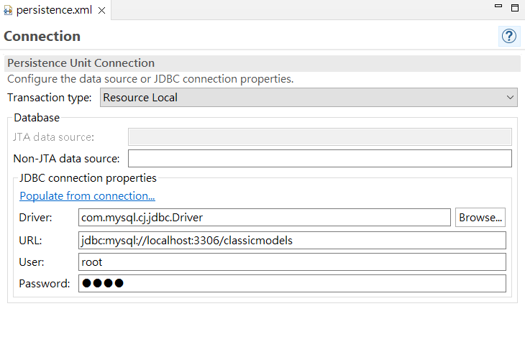
- 將關聯表格製作出來:
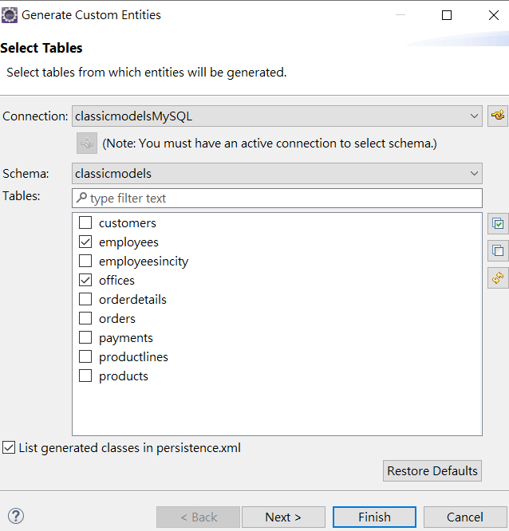
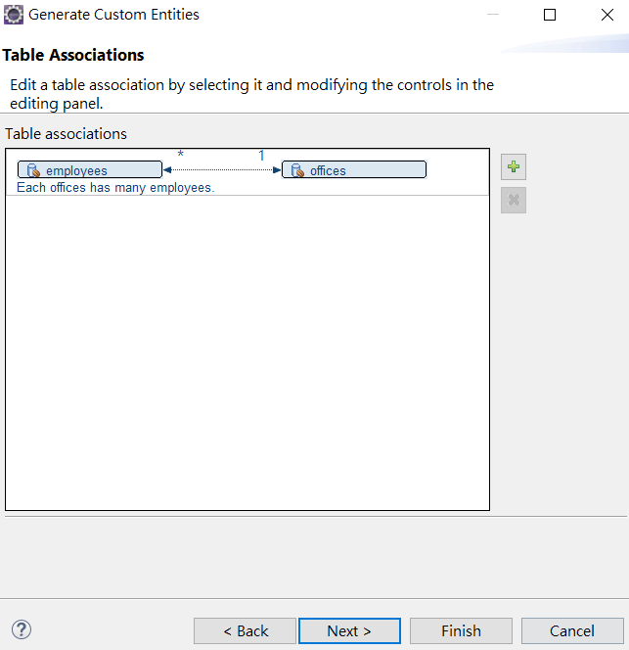
<?xml version="1.0" encoding="UTF-8"?>
<persistence version="2.2" xmlns="http://xmlns.jcp.org/xml/ns/persistence" xmlns:xsi="http://www.w3.org/2001/XMLSchema-instance" xsi:schemaLocation="http://xmlns.jcp.org/xml/ns/persistence http://xmlns.jcp.org/xml/ns/persistence/persistence_2_2.xsd">
<persistence-unit name="webJPA20230330" transaction-type="RESOURCE_LOCAL">
<class>model.Employee</class>
<class>model.Office</class>
<properties>
<property name="javax.persistence.jdbc.url" value="jdbc:mysql://localhost:3306/classicmodels"/>
<property name="javax.persistence.jdbc.user" value="root"/>
<property name="javax.persistence.jdbc.password" value="1234"/>
<property name="javax.persistence.jdbc.driver" value="com.mysql.cj.jdbc.Driver"/>
</properties>
</persistence-unit>
</persistence>

產生後之 Office.java Entity Class
package model;
import java.io.Serializable;
import javax.persistence.*;
import java.util.List;
@Entity
@Table(name="offices")
@NamedQuery(name="Office.findAll", query="SELECT o FROM Office o")
public class Office implements Serializable {
@Id
private String officeCode;
private String addressLine1;
private String addressLine2;
private String city;
private String country;
private String phone;
private String postalCode;
private String state;
private String territory;

//bi-directional many-to-one association to Employee
@OneToMany(mappedBy="office")
private List<Employee> employees;

public Office() {
}

public String getOfficeCode() {
return this.officeCode;
}

public void setOfficeCode(String officeCode) {
this.officeCode = officeCode;
}

public String getAddressLine1() {
return this.addressLine1;
}

public void setAddressLine1(String addressLine1) {
this.addressLine1 = addressLine1;
}

public String getAddressLine2() {
return this.addressLine2;
}

public void setAddressLine2(String addressLine2) {
this.addressLine2 = addressLine2;
}

public String getCity() {
return this.city;
}

public void setCity(String city) {
this.city = city;
}

public String getCountry() {
return this.country;
}

public void setCountry(String country) {
this.country = country;
}

public String getPhone() {
return this.phone;
}

public void setPhone(String phone) {
this.phone = phone;
}

public String getPostalCode() {
return this.postalCode;
}

public void setPostalCode(String postalCode) {
this.postalCode = postalCode;
}

public String getState() {
return this.state;
}

public void setState(String state) {
this.state = state;
}

public String getTerritory() {
return this.territory;
}

public void setTerritory(String territory) {
this.territory = territory;
}

public List<Employee> getEmployees() {
return this.employees;
}

public void setEmployees(List<Employee> employees) {
this.employees = employees;
}

public Employee addEmployee(Employee employee) {
getEmployees().add(employee);
employee.setOffice(this);

return employee;
}

public Employee removeEmployee(Employee employee) {
getEmployees().remove(employee);
employee.setOffice(null);

return employee;
}
}
產生後之 Employee.java Entity Class
package model;

import java.io.Serializable;
import javax.persistence.*;
@Entity
@Table(name="employees")
@NamedQuery(name="Employee.findAll", query="SELECT e FROM Employee e")
public class Employee implements Serializable {
private static final long serialVersionUID = 1L;

private String email;
@Id
private int employeeNumber;

private String extension;

private String firstName;

private String jobTitle;

private String lastName;

private int reportsTo;

//bi-directional many-to-one association to Office
@ManyToOne
@JoinColumn(name="officeCode")
private Office office;

public Employee() {
}

public String getEmail() {
return this.email;
}

public void setEmail(String email) {
this.email = email;
}

public int getEmployeeNumber() {
return this.employeeNumber;
}

public void setEmployeeNumber(int employeeNumber) {
this.employeeNumber = employeeNumber;
}

public String getExtension() {
return this.extension;
}

public void setExtension(String extension) {
this.extension = extension;
}

public String getFirstName() {
return this.firstName;
}

public void setFirstName(String firstName) {
this.firstName = firstName;
}

public String getJobTitle() {
return this.jobTitle;
}

public void setJobTitle(String jobTitle) {
this.jobTitle = jobTitle;
}

public String getLastName() {
return this.lastName;
}

public void setLastName(String lastName) {
this.lastName = lastName;
}

public int getReportsTo() {
return this.reportsTo;
}

public void setReportsTo(int reportsTo) {
this.reportsTo = reportsTo;
}

public Office getOffice() {
return this.office;
}

public void setOffice(Office office) {
this.office = office;
}
}

- 接下來建立Maven Spring Hibernate框架專案
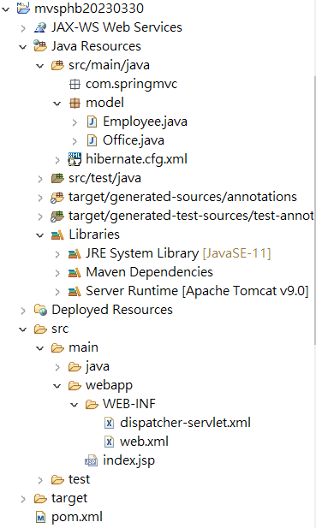
pom.xml
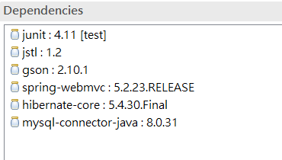
<dependency>
<groupId>jstl</groupId>
<artifactId>jstl</artifactId>
<version>1.2</version>
</dependency>
<dependency>
<groupId>com.google.code.gson</groupId>
<artifactId>gson</artifactId>
<version>2.10.1</version>
</dependency>
<dependency>
<groupId>org.springframework</groupId>
<artifactId>spring-webmvc</artifactId>
<version>5.2.23.RELEASE</version>
</dependency>
<dependency>
<groupId>org.hibernate</groupId>
<artifactId>hibernate-core</artifactId>
<version>5.4.30.Final</version>
</dependency>
<dependency>
<groupId>mysql</groupId>
<artifactId>mysql-connector-java</artifactId>
<version>8.0.31</version>
</dependency>

web.xml
<servlet>
<servlet-name>dispatcher</servlet-name>
<servlet-class>
org.springframework.web.servlet.DispatcherServlet
</servlet-class>
<load-on-startup>1</load-on-startup>
</servlet>
<servlet-mapping>
<servlet-name>dispatcher</servlet-name>
<url-pattern>/</url-pattern>
</servlet-mapping>
dispatcher-servlet.xml
<?xml version="1.0" encoding="UTF-8"?>
<beans xmlns="http://www.springframework.org/schema/beans"
xmlns:xsi="http://www.w3.org/2001/XMLSchema-instance"
xmlns:p="http://www.springframework.org/schema/p"
xmlns:context="http://www.springframework.org/schema/context"
xmlns:mvc="http://www.springframework.org/schema/mvc"
xsi:schemaLocation="http://www.springframework.org/schema/beans
http://www.springframework.org/schema/beans/spring-beans-4.1.xsd
http://www.springframework.org/schema/context
http://www.springframework.org/schema/context/spring-context-4.1.xsd
http://www.springframework.org/schema/mvc
http://www.springframework.org/schema/mvc/spring-mvc-4.1.xsd">

<context:component-scan base-package="com.springmvc"/>
<mvc:annotation-driven/>
<context:annotation-config/>
<bean class="org.springframework.web.servlet.view.InternalResourceViewResolver">
<property name="prefix">
<value>/WEB-INF/jsp/</value>
</property>
<property name="suffix">
<value>.jsp</value>
</property>
</bean>

</beans>
- src/main/java加入 hibernate.cfg.xml

<?xml version="1.0" encoding="UTF-8"?>
<!DOCTYPE hibernate-configuration PUBLIC "-//Hibernate/Hibernate Configuration DTD 3.0//EN"
"http://www.hibernate.org/dtd/hibernate-configuration-3.0.dtd">
<hibernate-configuration>
<session-factory name="hb0330">
<property name="hibernate.connection.driver_class">com.mysql.cj.jdbc.Driver</property>
<property name="hibernate.connection.password">1234</property>
<property name="hibernate.connection.url">jdbc:mysql://localhost:3306/classicmodels</property>
<property name="hibernate.connection.username">root</property>
<property name="hibernate.dialect">org.hibernate.dialect.MySQL5Dialect</property>
<mapping class="model.Office"/>
<mapping class="model.Employee"/>
</session-factory>
</hibernate-configuration>
- 先建立Spring View Home檢視輸入表單
package com.springmvc;
import org.springframework.stereotype.Controller;
import org.springframework.ui.ModelMap;
import org.springframework.web.bind.annotation.RequestMapping;

@Controller
public class OfficeEmployeeController {
@RequestMapping(value="/home")
public String home(ModelMap model) {
return "home";
}
}

home.jsp
<%@ page language="java" contentType="text/html; charset=UTF-8"
pageEncoding="UTF-8"%>
<!DOCTYPE html>
<html>
<head>
<meta charset="UTF-8">
<title>Office Employee</title>
<script src="http://ajax.googleapis.com/ajax/libs/jquery/3.6.0/jquery.min.js"></script>
</head>
<body>
<h3>Office Employee Entry Form</h3>
<form action="#" id="myForm">
<fieldset>
<legend>Office 基本資料:</legend>
<br/>
<label for="officeCode">辦公室編號:</label>
<input type="text" id="officeCode" name="officeCode" value="8">&nbsp;&nbsp;
<label for="city">城市:</label>
<input type="text" id="city" name="city" value="台北市"><br><br>
<label for="phone">電話:</label>
<input type="text" id="phone" name="phone" value="0223826015">&nbsp;&nbsp;
<label for="addressLine1">地址:</label>
<input type="text" id="addressLine1" name="addressLine1" value="公園路30號"><br><br>
<label for="country">國家:</label>
<input type="text" id="country" name="country" value="台灣">&nbsp;&nbsp;
<label for="postalCode">郵遞區號:</label>
<input type="text" id="postalCode" name="postalCode" value="100"><br><br>
<label for="territory">區域:</label>
<input type="text" id="territory" name="territory" value="Asia"><br><br>
</fieldset>
<fieldset>
<legend>Employee基本資料:</legend>
<br/>
<label for="employeeNumber">員工編號:</label>
<input type="text" id="employeeNumber" name="employeeNumber" value="1900"><br><br>
<label for="firstName">First Name:</label>
<input type="text" id="firstName" name="firstName" value="Janet">&nbsp;&nbsp;
<label for="lastName">Last Name:</label>
<input type="text" id="lastName" name="lastName" value="Chen"><br><br>
<label for="extension">分機:</label>
<input type="text" id="extension" name="extension" value="0x123">&nbsp;&nbsp;
<label for="email">Email:</label>
<input type="email" id="email" name="email" value="janet@demo.com"><br><br>

<label for="reportsTo">主管員編:</label>
<input type="text" id="reportsTo" name="reportsTo" value="1056">&nbsp;&nbsp;
<label for="jobTitle">職稱:</label>
<input type="text" id="jobTitle" name="jobTitle" value="Sales"><br><br>
<input type="button" id="addEmployee" value="Add Employee">
<input type="button" id="send" value="Send">
</fieldset>
</form>
<div id="msg"></div>
<script>
var EmpArry=[];
function addEmployee(){

var emp=new Object();
emp.employeeNumber=$("#employeeNumber").val();
emp.firstName=$("#firstName").val();
emp.lastName=$("#lastName").val();
emp.extension=$("#extension").val();
emp.email=$("#email").val();
emp.reportsTo=$("#reportsTo").val();
emp.jobTitle=$("#jobTitle").val();
emp.office=null;
EmpArry.push(emp);
alert(JSON.stringify(EmpArry));
}
function send() {
var offobj=new Object();
offobj.officeCode=$("#officeCode").val();
offobj.city=$("#city").val();
offobj.phone=$("#phone").val();
offobj.addressLine1=$("#addressLine1").val();
offobj.country=$("#country").val();
offobj.postalCode=$("#postalCode").val();
offobj.territory=$("#territory").val();
offobj.employees=EmpArry;

var value=JSON.stringify(offobj);
alert(value);

$.ajax("addOfficeEmployee",{
type:"post",
data: value,
contentType:"application/json", // 要送到server的資料型態
dataType:"html" , // 預期從server接收的資料型態
success: function (data, status) {
$("#msg").html(data);
},
error : function (data, status, errormsg) {
$("#msg").html(errormsg);
}
});

}
function mysubmit(evt){
evt.preventDefault();
return false;
}
$(document).ready(function() {
$("#myForm").submit(mysubmit);
$("#addEmployee").click(addEmployee);
$("#send").click(send);
});
</script>
</body>
</html>

最後製作OfficeEmployeeController.java

package com.springmvc;

import java.util.List;

import org.hibernate.*;
import org.hibernate.cfg.Configuration;
import org.springframework.stereotype.Controller;
import org.springframework.ui.ModelMap;
import org.springframework.web.bind.annotation.RequestBody;
import org.springframework.web.bind.annotation.RequestMapping;
import org.springframework.web.bind.annotation.RequestMethod;
import org.springframework.web.servlet.ModelAndView;

import model.*;

@Controller
public class OfficeEmployeeController {
@RequestMapping(value="/home")
public String home(ModelMap model) {
return "home";
}
// @RequestBody利用Google JSON 接收前端傳送過來控制器由supplier接收
@RequestMapping(value = "/addOfficeEmployee", method = RequestMethod.POST)
public ModelAndView addOfficeEmp(@RequestBody Office office, ModelMap modelMap) {
Office sup = office;
List<Employee> emps = sup.getEmployees();
//將員工(emplyee)指定儲存Office資料
for(int i=0;i<sup.getEmployees().size();i++) {
emps.get(i).setOffice(office);
}

modelMap.addAttribute("emps", emps);
modelMap.addAttribute("office", office);
save(office);
return new ModelAndView("showOffice");
}
public void save(Office office) {
SessionFactory factory=null;
try {
factory=new Configuration().configure().buildSessionFactory();
Session ss=factory.openSession();
ss.getTransaction().begin();
ss.saveOrUpdate(office);
ss.getTransaction().commit();
}catch(Exception ex) {
System.out.println("hibernate error:"+ex.getMessage());
}
}
}

